



User Manual

Preamble

All rights reserved. No parts of this work may be reproduced in any form or by any means – graphic, electronic, or mechanical, including photocopying, recording, taping, or information storage and retrieval systems – without the written permission of the publisher.

Products that are referred to in this document may be either trademarks and / or registered trademarks of the respective owners. The publisher and the author make no claim to these trademarks.

While every precaution has been taken in the preparation of this document, the publisher and the author assume no responsibility for errors or omissions, or for damages resulting from the use of information contained in this document or from the use of programs and source code that may accompany it. In no event shall the publisher and the author be liable for any loss of profit or any other commercial damage caused or alleged to have been caused directly or indirectly by this document.

This manual is prepared for TEACHERS. As teachers, you will be responsible for entering your individual grades, as well as entering student’s daily attendance. You will be able to do more than just entering grades and attendance. You will also have a personal grade book which shows your students’ performance as you are entering grades.
Part I - Starting iLearn

To start iLearn double click the icon named iLearn on your desktop.
Alternatively, you can locate it from your Start menu under the folder iLearn.

Part II - Login

You must enter a user name and password to access iLearn. The administrator will provide you with an individual login that has been created for you.

After starting iLearn, you will be presented with the login screen below:

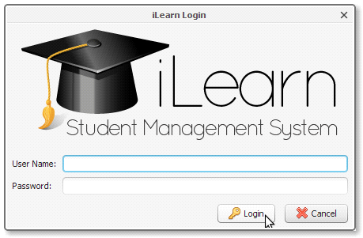

Type in the user name and password given to you by the administrator and click the Login button. If login is successful, the login window will disappear and the program will load the main window.

If your user name and / or password do not match those on file, you will be asked to enter them again. You have three chances to login before the program exits.

Part III - Main Window

Once you have successfully logged on, the following login screen will appear:



By default, teachers will have some features disabled. All information will already be created before you begin using the program. Heads of Department will have extra privileges because they will be able to see the grade books for teachers in their department.

Changing Password

After being issued the login password, it is recommended to change it for greater security. To change the password, select File → Change Password from the Main Menu. The following box will appear:
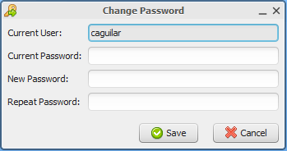
The user currently logged in will appear in an un-editable form. You must enter the current password assigned to you. Enter any new password you like. Re-enter your new password and select Save.
If the Current Password entered does not match your original login, the password will not change. Below is an example:

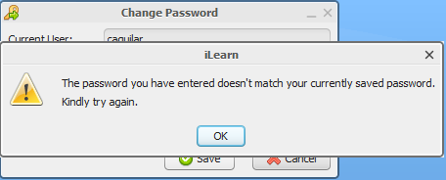

Logging Off
If another teacher wishes to use iLearn when one teacher is finished, the log out feature allows you to do so. To log out of iLearn, select File→ Logout from the Main Menu. You will be asked if you would like to log off. Select Yes to logoff and No to remain logged on to the program.
Logoff does NOT close iLearn. It simply displays the login window again with the main menu in the background disabled. Clicking on Cancel on the login window will then close the program.
Exiting the Program
To properly exit iLearn, select File→ Exit. You will be asked if you would like to exit the program. Select Yes to exit and No to remain in the program. You may also click on the X button located on the upper right hand corner of the screen. Again, select Yes to close and No to remain in the program.

Part IV- Entering Grades

To enter grades into the program select Grades → Record Grades from the Main Menu. The following dialog box will appear:

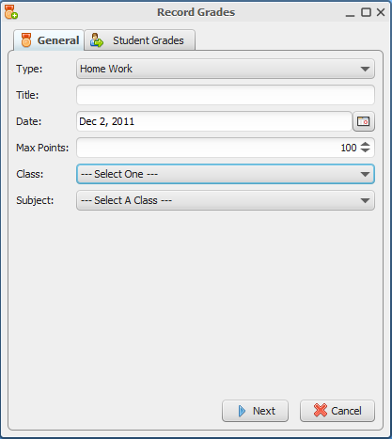

ALL of the following fields must be filled out before being able to enter the grades for your students:

Type: - This field is the type of assessment given. Examples include Quiz, Test, Homework, Project, Presentation etc. Click on the arrow located at the right hand side of the field and choose the appropriate assessment from the drop down list.

Title: - This field is the name of the assessment given. Examples include Number Theory, The Digestive System, Database Management.

Date: - This field is the date the assessment was given. Click on the icon to the right hand side of the field to select the date.

Max Points: - This field is the Total Points allotted for the current assessment. The points may be increased or decreased by click on the arrows to the right of the field or by highlighting the default number, 100, and manually typing in the points.

Class: - This field is the class for which the assessment was given. Examples include 1A, 2B, 3A, etc.

Subject: - This is the subject that you teach. Examples include Math, Science, English.

Only the classes and subjects that you teach will be available to you to enter.

If one field is not entered, you will be told which filed was not filled out. Once all fields have been filled out, you will be taken to the screen to enter the respective assessment created. The following screen will appear:

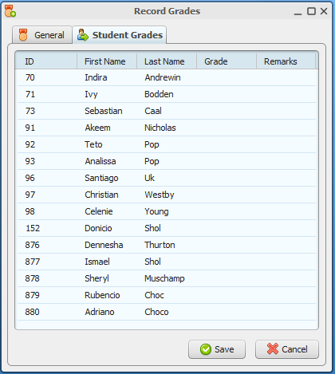

Click on the Last Name column heading if the students’ names do not appear in alphabetical order. This will sort their names alphabetically in descending order.

Click under the Grade column heading next to the student name and enter the student’s respective grade. Any remark on the grade may be entered as well. Click on the next student’s name and type his or her respective grade. Currently, you need to click on the individual grade fields to enter the grade.
Once all grades have been entered, click on the Save button located at the bottom right hand corner of the dialog box. You will be prompted to enter another assessment. If you wish to enter another assessment, select Yes on the dialog box that appears, otherwise select No to close the window.

If you have entered a grade that is higher than the Max Points, you will be given a warning message telling you which student’s grade is greater than the maximum points.

Editing Grades

In the event that an assessment needs to be edited in any way, there is an option to do so. To edit any grade, select Grades → Edit Grades from the Main Menu. The following dialog box will appear:

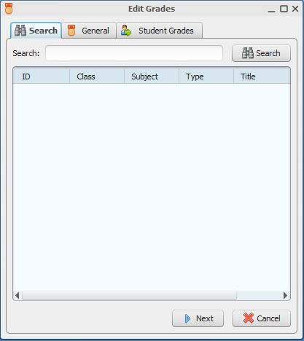

In the search box, enter assessment name to be edited and click on the Search button located at the right hand side of the Search Field.

The assessment entered or assessments with similar names will appear.
- Click once on the assessment to be edited and click on Next located at the bottom right hand corner of the dialog box. This will bring up the information on the assessment created. Under this menu, you will be able to change the assessment name, type, points, date, class and subject in the event an error was made entering the grades.

- Double clicking on the assessment to be edited will automatically take you to the students’ grades entered.
Once you have done any of the above you may switch between the General and Students Grades Tabs in the event you need to edit both assessment and individual students’ grades.

Once all corrections have been made, go to the Students Grades Tab and click Save located at the bottom right hand corner of the dialog box. If you wish to undo any changes, select Cancel to close off the Edit Grades Menu.

Removing Grades

If any assessment needs to be removed, there is an option to do so. Select Grades → Remove Grade from the Main Menu. The same dialog box as Edit Grades will appear. Type in the name of the assessment to be removed and click the Search button.

Double click on the assessment to be removed or click once on the assessment and click Next. Only the information on the assessment will appear. Students’ grades will not appear under this menu. Click on the Remove Grade button located at the bottom right hand corner the dialog box. You will be asked to confirm the removal of this assessment. Click Yes to remove the assessment or No to cancel.

Part V- Electronic Grade book

Each teacher has his or her personal electronic grade book that keeps track of their student’s performance. As each assessment is being entered, teachers are able to see each student’s average for the subject. Other evaluations are also done automatically on this grade book such as:
- The Lowest Grade obtained
- The Average Class Grade
- The Number and Percentage of Students who passed
- The Number and Percentage of Students who failed

To access your individual grade book, select Reports → Class → Class Gradebook from the Main Menu. The following menu will appear:

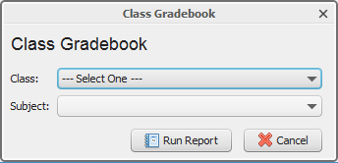

Click on the bar and choose the Class you wish to see. After selecting the Class, click on the next bar and choose the Subject.

Only the classes and subjects you teach will be available for you to choose in the drop down list.

After selecting both fields, click on Run Report. You will be prompted to give the grade book a name. Give any name you like and click Save. Give the program a few seconds to load the report. The grade book report will be shown in Microsoft Excel. Adjust the column widths so you are able to see all the information regarding the assessments already entered.

Part VI- Attendance

Homeroom teachers will be responsible for entering the daily attendance into the program. To access students’ attendance, select Attendance → Enter Attendance from the Main Menu. The following dialog box will appear:

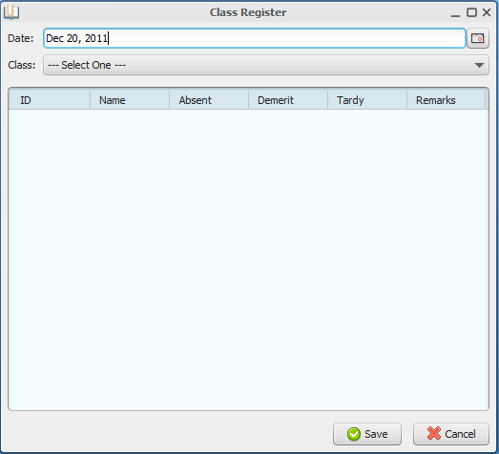

Click on the calendar to the right of the Date field to choose the date for which the attendance will be entered. After choosing the date, click on the bar next to the Class field name and select the class for which the attendance will be entered.

A screen similar to the following will appear:

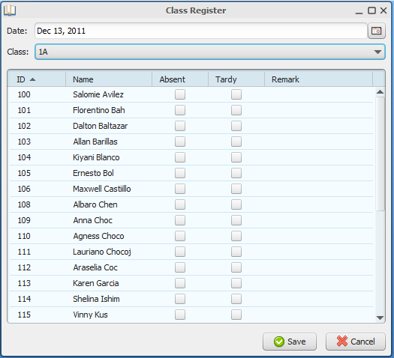

No action needs to be taken for students who are present and on time. For students who are absent simply click the check box next to their names under the column heading Absent. Similarly, click in the check box next to the students’ names under the column heading Tardy for students who are late. Remarks may also be entered for each student if a reason was given for their absence or tardiness. If a demerit was issued for either one, that may be placed under Remark as well.

Click on the Save button located at the bottom right hand side of the dialog box to store the register for that day. You will be given a confirmation message. You will also be prompted to enter another day. Select Yes to continue updating the register, or No to close off the Register.

If no student is neither Absent nor Tardy, simply click the Save button.

The Cancel button will undo any changes made to the register if the Save button has not been clicked.

Edit Attendance

If the attendance register needs to be edited, that feature may be accessed by selecting Attendance → Edit Attendance from the Main Menu.

A slightly different dialog box than the Class Register will appear:

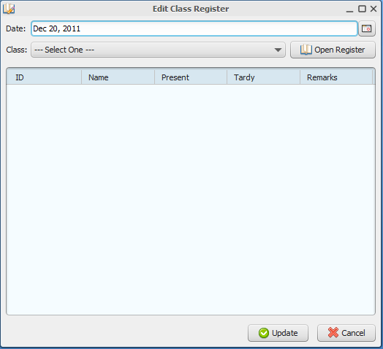

Choose the date then the class that needs to be updated. After choosing the correct date and class, click on Open Register located at the right hand side of the Class Field. The information saved from that date will appear. Edit the respective student and click on the Update Button.

